GSL application problems in C++ Project with Visual Studio 2019 and Windows 10.
To: help-gsl-request @gnu.org
Subject: subscribe
---------------------------------------------------------------------------------------------------
Dear GSL engineers,
I am writing to ask for your help with my GSL application. The following appendix instructions are detailed processing information causing my fatal error.
Thank you ahead for your kind reply!

---------------------------------------------------------------------------------------------------
Appendix
- Application purpose:
Apply GSL to my C++ projects in Window 10 System with Visual Studio 2019.
- Part I:
- Windows 10 operation system (64 bits):
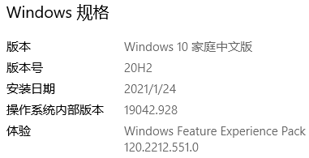
- Visual Studio 2019:
Visual Studio 2019 community version.

- CMake:
version 3.20.2;

- GSL:
It is configured as the instructions in following website (“Install GSL on Windows”):
https://solarianprogrammer.com/2020/01/26/getting-started-gsl-gnu-scientific-library-windows-macos-linux/

- step 1: git
version 2.31.1 for Windows, installed as default recommendations.
- step 2: vcpkg & GSL
GSL version 2.6.
(steps are as following shortcuts)
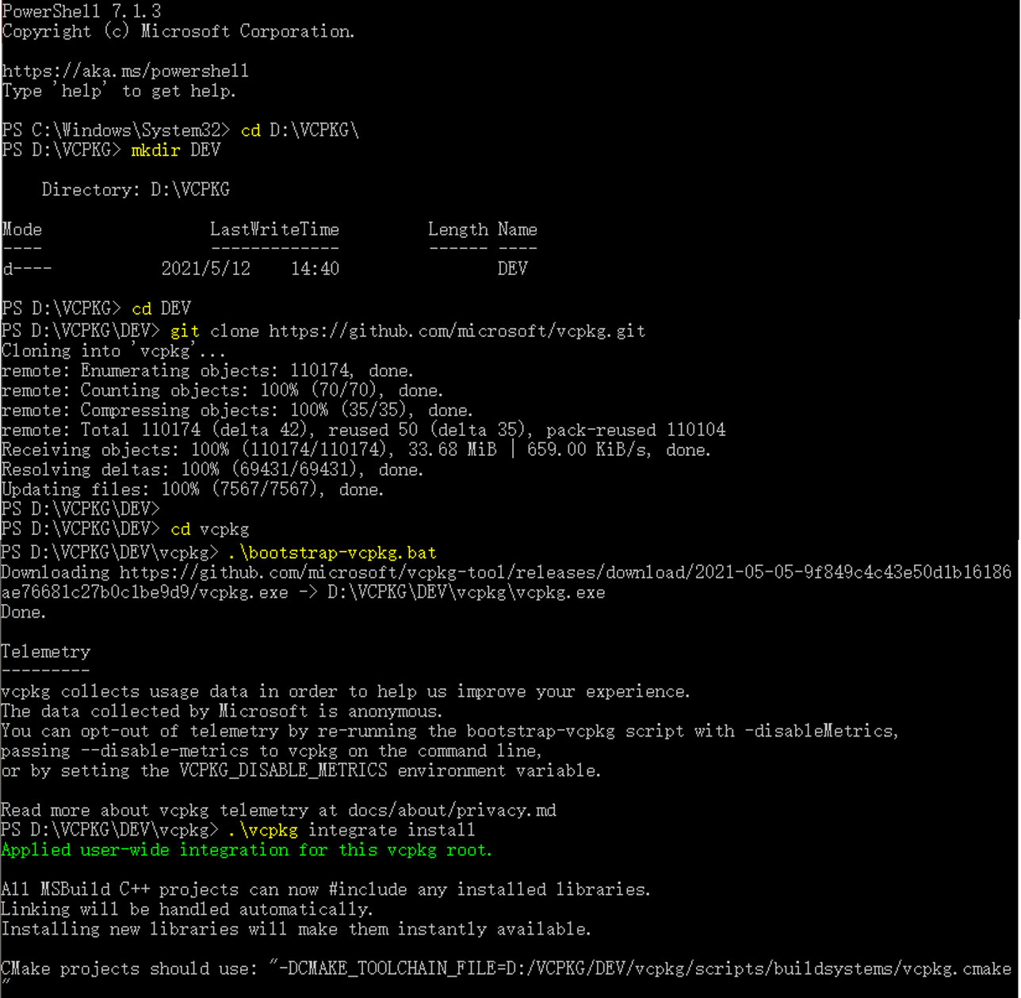
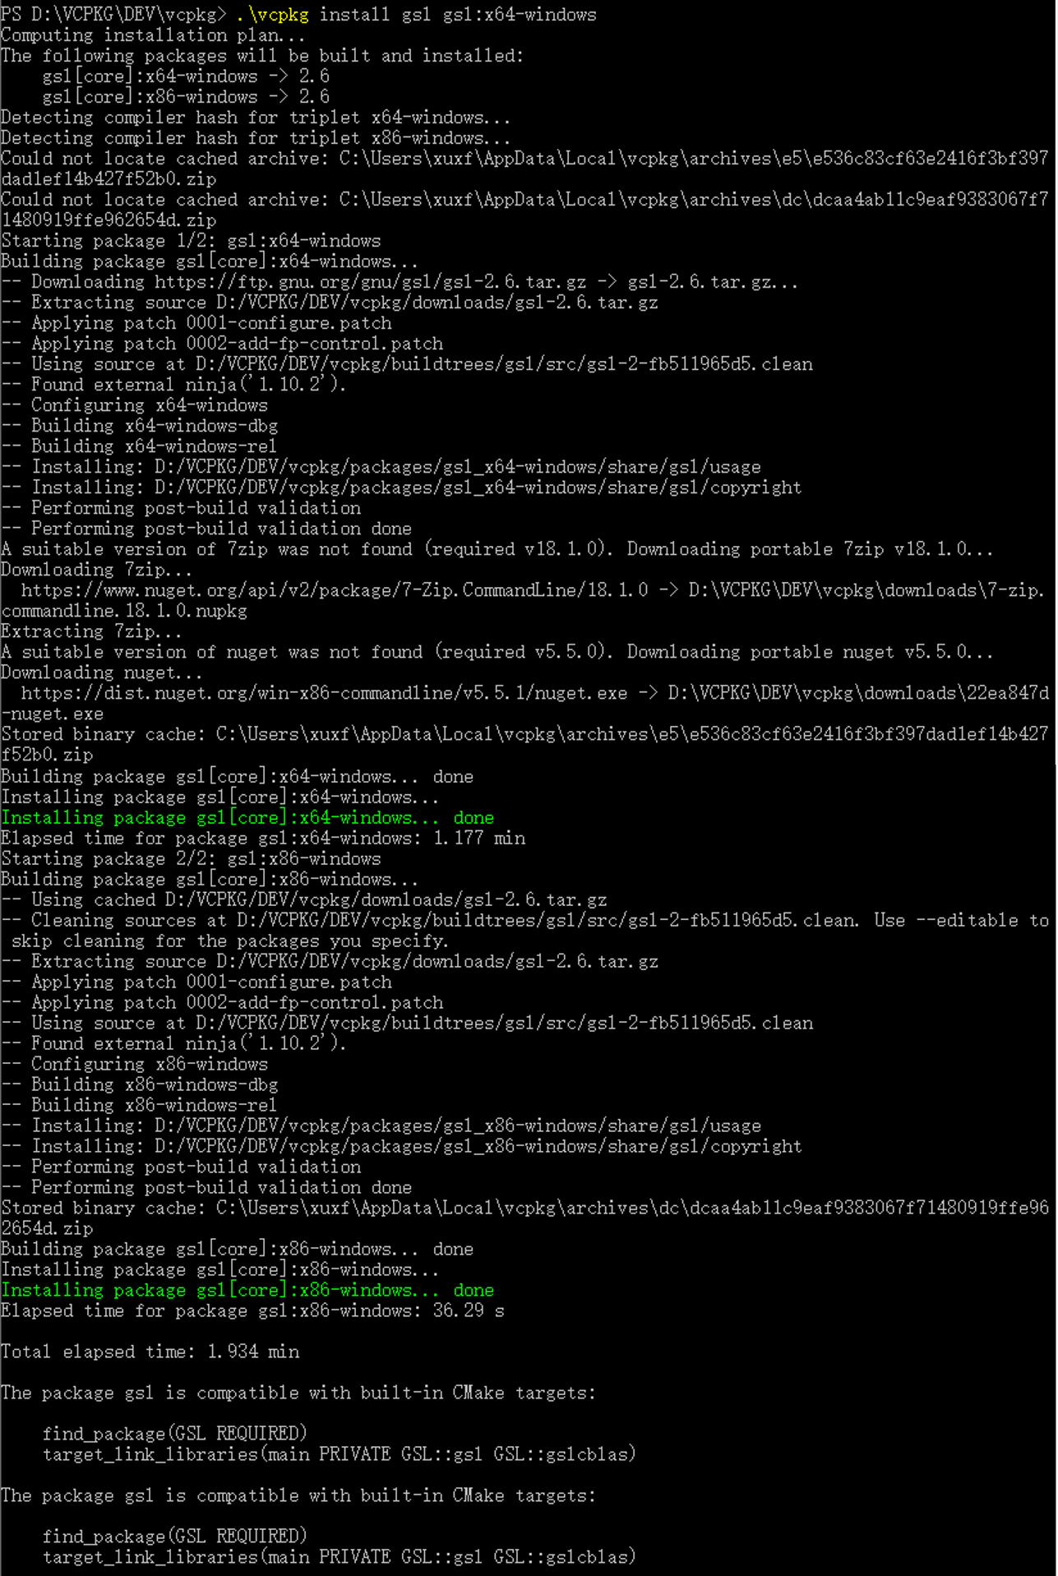
- step 3: write a CMakeList.txt
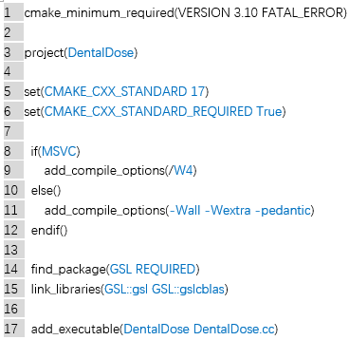
- step 4: testing project
project name: DentalDose;
project main: DentalDose.cc;
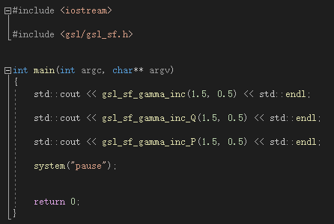
- step 5: Apply Cmake to configure and build the project.
ERROR:
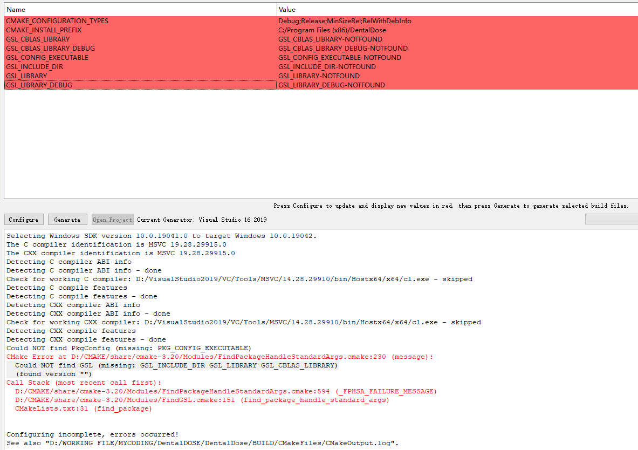

---------------------------------------------------------------------------------------------------
Would you please help me analyze the above “ERROR” and refer me to some possible solutions? Thank you very much!

